## Anna University - Wikipedia Naan Mudhalvan – KCG College of Technology

## 

**GOVERNMENT COLLEGE OF ENGINEERING [IRTT]**

 **ERODE: 638 316**

**Electronics and Communication Engineering**

**NAAN MUDHALVAN**

**TEAM ID: NM2023TMID04457**

***SB8056 – Digital Marketing***

***by Naan Mudhalvan Scheme – 2023***

**PROJECT DOMAIN: DIGITAL MARKETING**

**PROJECT TITLE: BUILDING A WEBSITE USING CANVA**

BRAND NAME: SYMPHONY SIPS

CATEGORY: BOOK CAFE

**TEAM MEMBERS**

|  |  |
| --- | --- |
| **REGISTER NUMBER** | **NAME** |
| **731120106044** | **YUVASRI K** |
| **731120106041** | **VIMAL PRIYA M** |
| **731120106038** | **VARSHA DEVI N** |
| **731120106018** | **NANDHINI J** |

**GOVERNMENT COLLEGE OF ENGINEERING (Formerly IRTT)**

**ERODE-638 316**



**BONAFIDE CERTIFICATE**

Certified that this project titled “**BUILDING A WEBSITE USING CANVA**" is the bonafide work of **YUVASRI K** (**731120106044**), **VIMAL PRIYA M** (**731120106041**), **VARSHA DEVI N** (**731120106038**), **NANDHINI J** (**731120106018**) who carried out the project work under my supervision.

**SIGNATURE OF FACULTY EVALUATOR** **SIGNATURE OF FACULTY MENTOR**

**Dr.S.BHARATHI, M.Tech.,Ph.D** Dr.S.BHARATHI, M.Tech.,Ph.D

ASSISTANT PROFESSOR, ASSISTANT PROFESSOR ,

DEPARTMENT OF ECE, DEPARTMENT OF ECE,

GOVERNMENT COLLEGE OF ENGINEERING, GOVERNMENT COLLEGE OF ENGINEERING,

ERODE- 638316 ERODE- 638316

**SIGNATURE OF SPOC**  **SIGNATURE OF HOD**

Dr.K.MURUGAN, M.E,Ph.D, Dr.R.VALARMATHI, M.E,Ph.D,

ASSISTANT PROFESSOR, PROFESSOR/HEAD OF THE DEPARTMENT,

DEPARTMENT OF IT, DEPARTMENT OF ECE,

GOVERNMENT COLLEGE OF ENGINEERING, GOVERNMENT COLLEGE OF ENGINEERING,

ERODE- 638316. ERODE-638316

**ABSTRACT**

Building a Website Using Canva

The project is a strategic endeavour to extend the reach and impact of a cozy book cafe by establishing a compelling online presence. The name of the brand is SYMPHONY SIPS. This initiative encompasses comprehensive project planning, website design, content creation, Canva-driven graphic design, website development, rigorous testing, successful launch, strategic promotion, and ongoing maintenance. The primary objectives are to promote the cafe, facilitate online book orders, and nurture an online community of book enthusiasts. This abstract offers a concise overview of the project's core components and objectives, providing a glimpse of the comprehensive report that follows.

**TABLE OF CONTENTS**

CONTENTS Page No

**1.INTRODUCTION 1**

1.1 Project Overview

1.2 Purpose and Objectives

**2. BRAINSTORMING AND IDEATION PHASE 7**

2.1 Problem Statement and Understanding

2.2 Empathy Map Canvas

2.3 Brainstorming and Ideation Phase

**3. PROJECT FLOW AND ANALYSIS 13**

3.1 Functional requirement

3.2 Non-Functional requirements

**4.PROJECT DESIGN PHASES 17**

4.1 Data Flow Diagram

4.2 Solution & Technical Architecture

4.3 User Stories

**5. PROJECT DESIGN 24**

5.1 User-Centric Navigation Design

5.2 Branding Integration and Customization

5.3 Responsive Design

**6.DIGITAL MARKETING STRATEGY 30**

6.1 Rationale for chosen digital channels and platforms

6.2 Key messaging and branding decisions

**7. IMPLEMENTATION PLAN 32**

**8. RESULT AND ANALYSIS 43**

**9. RECOMMENDATION FOR THE FUTURE 44**

**10. SCOPE OF THE PROJECT 47**

**11. CONCLUSION 49**

**12.APPENDIX 49**

**1.INTRODUCTION:**

* 1. PROJECT OVERVIEW:

The project, "Building a Website for the Book Cafe Using Canva," is a comprehensive initiative aimed at creating a dynamic and engaging online platform for a book cafe. The project's primary objective is to establish a strong digital presence that complements the book cafe's physical presence, provides valuable information to customers, fosters a sense of community among book enthusiasts, and ultimately promotes the book cafe's offerings. Below is an overview of the key aspects of the project:

BACKGROUND:

The book cafe, known for its cozy atmosphere and extensive collection of books, seeks to expand its reach by launching a website. The website is intended to act as an extension of the cafe, catering to a broader audience and enhancing the overall customer experience.

1.2. PURPOSE AND OBJEVTIVES:

The project's purpose is to design and develop a website that not only represents the book cafe's unique identity but also serves several strategic objectives:

1. Promotion:

To promote the book cafe's physical and virtual presence, increasing its visibility and attracting new customers.

1. Online Ordering:

To provide a platform for online book ordering, extending the cafe's services to the digital realm.

1. Community Building:

To foster an online community of book enthusiasts, offering a space for discussions, events, and shared interests.

**2.** **BRAINSTORMING AND IDEATION PHASE**

2.1 PROBLEM STATEMENT AND UNDERSTANDING:

Problem Statement:

The book cafe currently relies solely on its physical presence to attract customers and build a community of book enthusiasts. In an increasingly digital world, the absence of an online platform limits its outreach and the ability to engage with potential customers. Furthermore, the lack of online ordering options hinders revenue generation.

Understanding of the Project:

* The project aims to bridge the digital divide by creating an attractive and user-friendly website that mirrors the cafe's unique charm while providing a digital extension of its offerings.
* It seeks to overcome the absence of online ordering facilities by offering a seamless, user-friendly online ordering system, enhancing customer convenience and revenue opportunities.
* The project recognizes the potential of fostering an online community of book enthusiasts through a blog, event updates, and discussion forums, amplifying the cafe's presence beyond its physical location.
* Through the utilization of Canva's graphic design capabilities, the project endeavours to ensure that the website's visual elements align with the cafe's ambiance and branding.
* By addressing these issues and leveraging the project's understanding, we aim to create a dynamic online presence for the book cafe, enhancing customer engagement and expanding its reach.

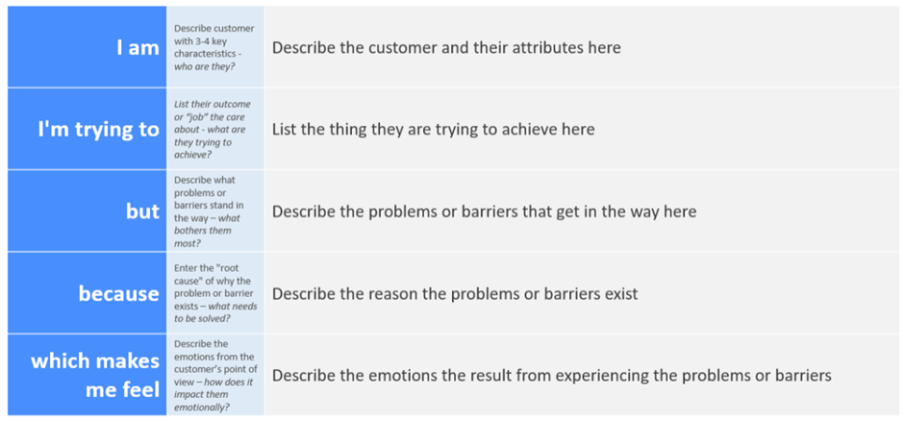

Example:

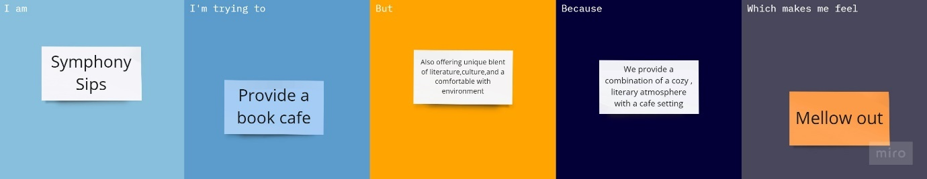

|  |  |  |  |  |  |
| --- | --- | --- | --- | --- | --- |
| **Problem Statement (PS)** | **I am (Customer)** | **I’m trying to** | **But** | **Because** | **Which makes me feel** |
| PS-1 | Noise Disturbance | Find that may I be bothered by noise from other patrons, loud conservation or disruptive behaviour | Maintain a welcoming and peaceful environment | The wrong reviews are given | The quiet and peaceful environment can encourage introspection and deep thinking. |
| PS-2 | Book Availability | Encounter the cafe has a limited book selection or lacks specific titles. | It does not disappoint customers | The ambiance is cozy, and the book selection is fantastic. | Many people feel grateful for having a place that combines their love for books and a relaxing environment |

2.2 EMPATHY MAP CANVAS:

An Empathy Map is a visual tool and framework used in design thinking and user-centered design processes to gain a deeper understanding of a particular audience or user group. It helps to capture insights about the thoughts, feelings, needs, and experiences of the target audience. Empathy Maps are typically used to foster empathy and create a more human-centered approach to problem-solving and design.

Target Persona: Book Enthusiasts

Says:

* "Book enthusiasts often seek places with a welcoming ambiance to read."
* "They express a desire for book cafes where they can enjoy a good book."
* "Many discuss their experiences browsing bookstores and libraries."

Thinks:

* "Book enthusiasts typically want to discover new books and access recommendations."
* "They look for book cafes that offer a comfortable reading space and diverse book collections."
* "They consider the importance of connecting with fellow readers and engaging in book-related discussions."

Does:

* This audience often conducts online and offline searches for book cafes and literary events.
* They frequently visit bookstores, libraries, and book cafes to explore book collections.
* Many book enthusiasts engage in online book clubs and reading communities.

Feels:

* Book enthusiasts commonly experience excitement when they find a suitable reading environment.
* Frustration may arise when they can't locate a welcoming place to read.
* There is an eagerness to connect with a community of book lovers.

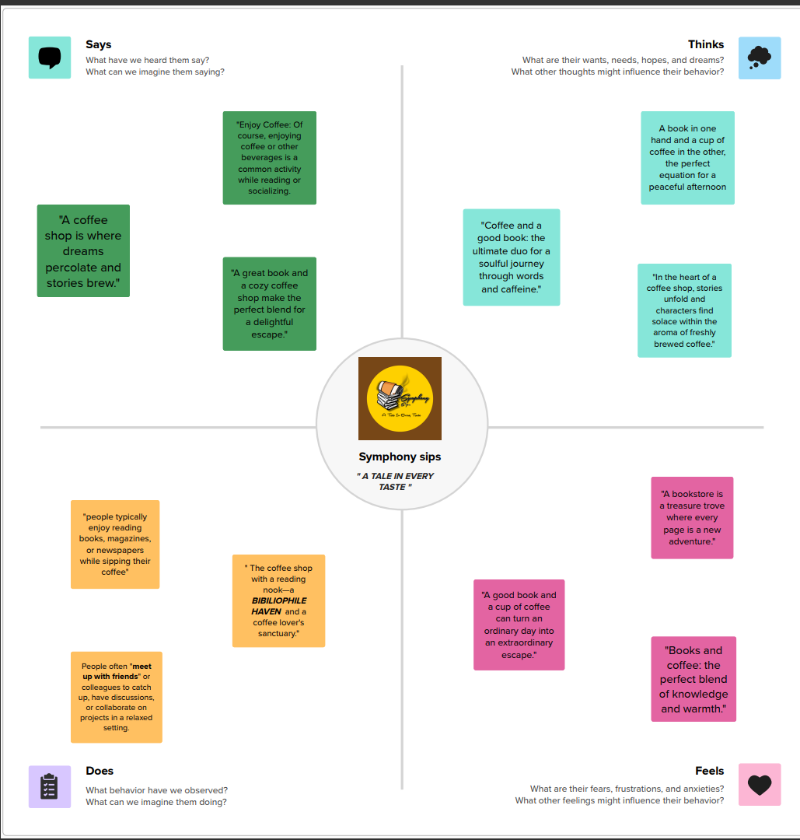

2.3 BRAINSTROMING AND IDEATION PHASE:

Brainstorming provides a free and open environment that encourages everyone within a team to participate in the creative thinking process that leads to problem solving. Prioritizing volume over value, out-of-the-box ideas are welcome and built upon, and all participants are encouraged to collaborate, helping each other develop a rich number of creative solutions.

Use this template in your own brainstorming sessions so your team can unleash their imagination and start shaping concepts even if you're not sitting in the same room.

Step-1: Team Gathering, Collaboration and Select the Problem statement

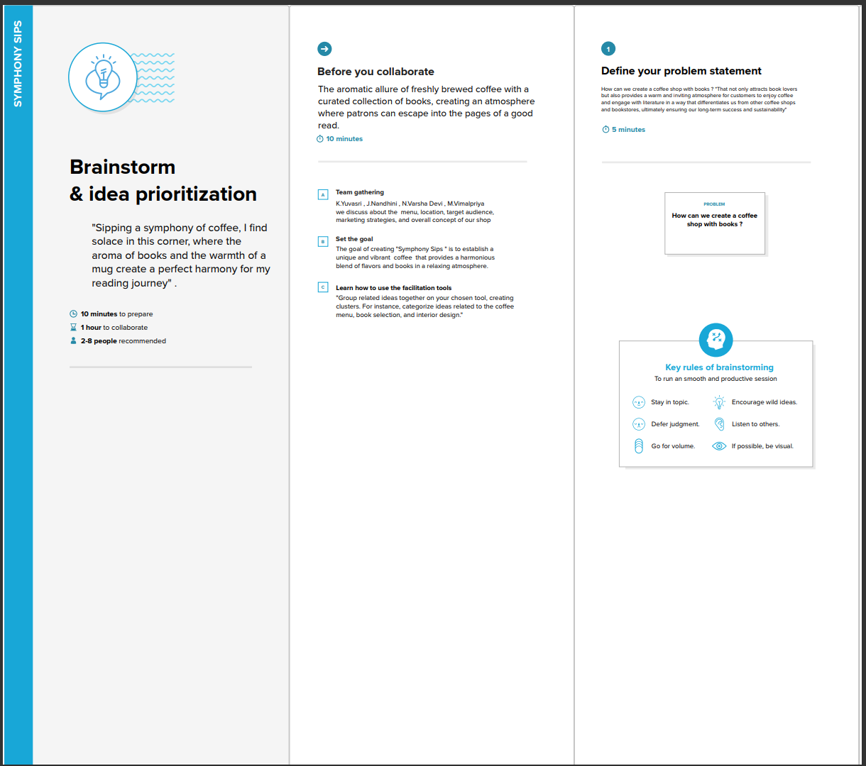

Step-2: Brainstorm, Idea Listing and Grouping

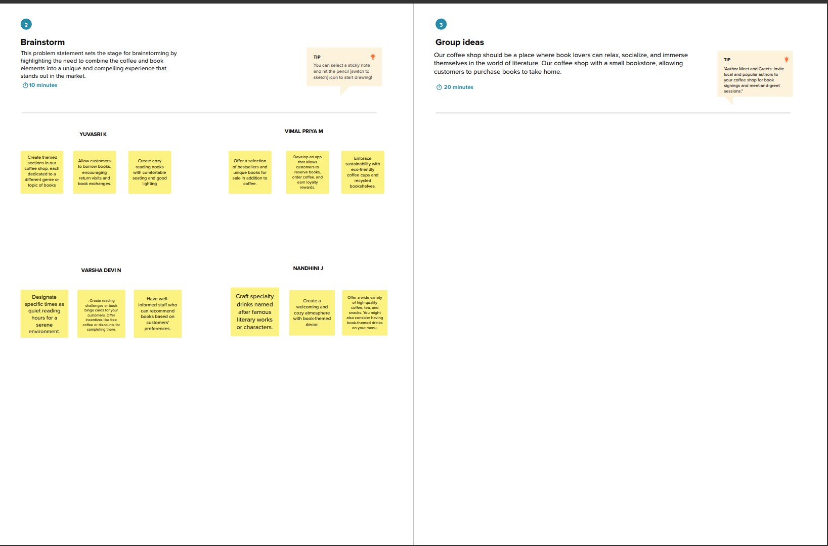

Step-3: Idea Prioritization

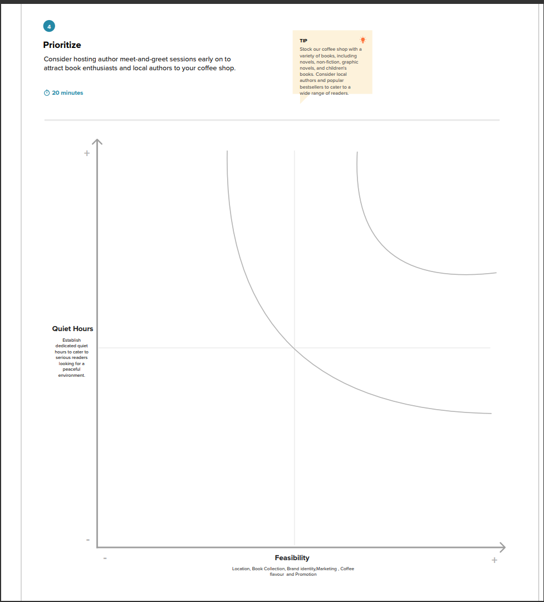

**3. PROJECT FLOW AND ANALYSIS**

In this section, we delve into the structural and analytical aspects of the project, outlining how it functions and what criteria it must meet. It is crucial to establish the project's functional and non-functional requirements to ensure a well-rounded development process.

* 1. FUNCTIONAL REQUIREMENTS:

Functional requirements define what the project must do in terms of specific functions and features. These are the core capabilities that the project should provide to fulfil its purpose effectively. Key elements of the functional requirements include:

* User Registration:

The system should allow users to register and create accounts.

* Book Catalog:

A comprehensive catalog of books with search and filter options.

* User Profiles:

User profiles with personalization features.

* Online Booking:

A system for reserving tables and books online.

* Secure Payment Gateway:

Secure online payment for book purchases and orders.

* Community Forums:

Forums for book discussions and interactions.

* Event Calendar:

A calendar for listing book-related events and activities.

* Content Management:

Tools for managing and updating website content.

* Notifications:

Email and in-app notifications for users.

* Feedback and Support:

Mechanisms for user feedback and customer support.

3.2 NON-FUNCTIONAL REQUIREMENTS:

Non-functional requirements relate to the performance, security, and quality attributes of the project. These aspects are equally important for the project's success, as they ensure it functions optimally and provides a satisfactory user experience. Key non-functional requirements include:

* Performance:

The website should load quickly and respond to user interactions promptly.

* Security:

Data security measures to protect user information and transactions.

* Scalability:

The ability to handle increasing numbers of users and content.

* Usability:

The website should be user-friendly and accessible to a wide range of users.

* Compatibility:

Cross-browser and cross-device compatibility for a seamless user experience.

* Reliability:

The website should be available and functional 24/7 with minimal downtime.

* Data Backup and Recovery:

Regular data backups and a robust recovery plan.

* Compliance:

Adherence to legal and regulatory requirements, such as data privacy laws.

* Load Testing:

Testing the website's performance under heavy traffic conditions.

* Security Audits:

Regular security audits and updates to protect against cyber threats.

**4.PROJECT DESIGN PHASES**

4.1 DATA FLOW DIAGRAM:

A Data Flow Diagram (DFD) is a visual representation that illustrates how data moves within a system or process. It uses symbols and arrows to show how data is input, processed, stored, and output within the system, providing a clear and concise overview of data flow and interactions. DFDs are useful for understanding and designing systems, particularly in software development and business processes.

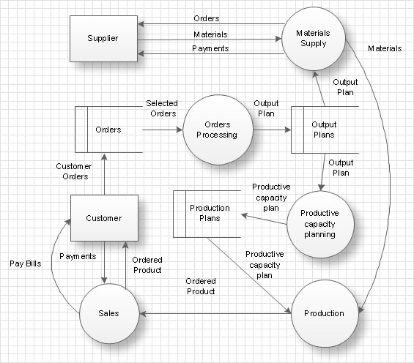

4.2 SOLUTION & TECHNICAL ARCHITECTURE:

**Solution Architecture:**

Our Coffee shop with a reading book theme aims to provide a tranquil and inviting atmosphere for book enthusiasts. We offer:

* + Designated areas with minimal noise to allow customers to focus on their books.
  + Well-lit spaces with large windows or natural light sources for comfortable reading.
  + Comfortable chairs and seating arrangements designed for extended reading sessions.
  + A diverse library of books available for customers to borrow or purchase.
  + Consistent access to high-speed Wi-Fi and numerous power

**Solution Architecture Diagram:**

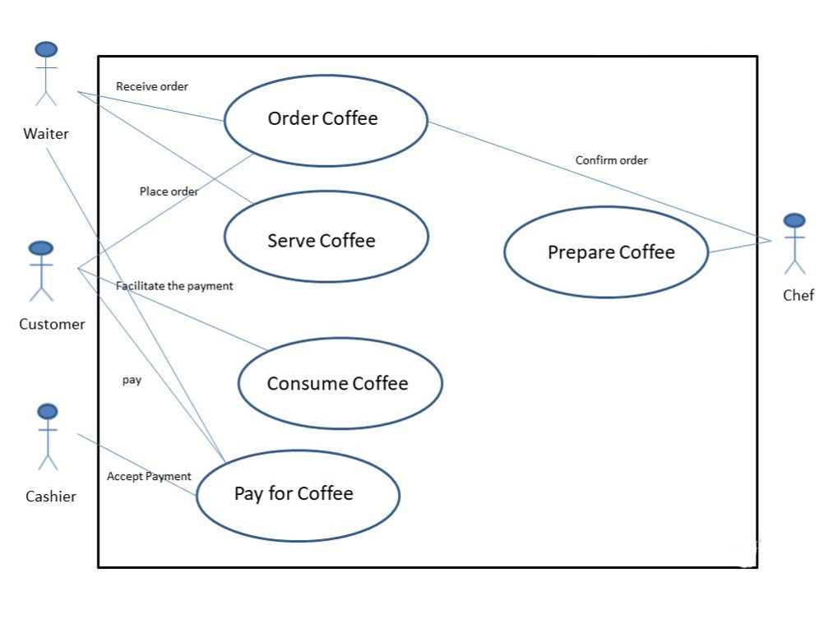

**Table-1: Components & Technologies:**

|  |  |  |  |
| --- | --- | --- | --- |
| **S.NO** | **Component** | **Description** | **Technology** |
|  | Location | Select a suitable location for the cafe, taking into account factors like foot traffic, accessibility, and proximity to your target. | Geographic Information Systems (GIS) and mapping tools. |
|  | Space and Layout | Plan the interior design and layout of the cafe to accommodate seating, a kitchen area, counter space, and any additional features like outdoor seating. | Implement Computer-Aided Design (CAD) software for efficient cafe layout planning. |
|  | Equipment | Acquire the necessary equipment, including coffee machines, grinders, ovens, refrigerators, dishwashers, and furniture. | Integrate IoT-enabled and smart appliances for operational efficiency. |
|  | Menu | Develop a menu that includes coffee, tea, pastries, sandwiches, salads, or any other food and beverage items you plan to offer. | Employ digital menu boards and POS systems for dynamic and efficient menu management. |
|  | Staffing | Hire and train baristas, kitchen staff, servers, and any other personnel required to run the cafe efficiently. | Scheduling and HR management software |
|  | Suppliers | Establish relationships with suppliers for coffee beans, baked goods, and other ingredients to ensure a consistent and quality supply of products. | Implement procurement and supply chain management software for automated supplier interactions. |
|  | Books | Stock a variety of books, including novels, non-fiction, and children's books. | Offer e-books and e-readers, with e-reader devices and management platforms. |
|  | Wi-Fi | Provide Wi-Fi access for customers who want to work or study. | Provide secure Wi-Fi using Wi-Fi management software. |
|  | Reservation System | An online reservation system allows customers to book tables, enhancing user experience and streamlining cafe operations. | HTML,CSS,JavaScript |
|  | SEO Integration | Basic SEO practices improve the website's visibility in search engine results, attracting more organic traffic. | SEO tools, plugins, and best practices. |

**Table-2: Application Characteristics:**

| **S. No** | **Characteristics** | **Description** | **Technology** |
| --- | --- | --- | --- |
|  | Scalability | The website should be able to handle increased user traffic and content growth. | Scalable hosting infrastructure and CMS. |
|  | Security | Implement robust security measures to protect user data and safeguard against cyber threats. | SSL, security plugins, encryption. |
|  | Performance | Ensure the website loads quickly and offers a smooth user experience. | Content optimization, fast hosting. |
|  | User-Friendly Interface | Create an intuitive and visually appealing design for a positive user experience. | Responsive web design, user interface design. |
|  | SEO-Friendly | Implement SEO best practices to improve search engine visibility. | SEO tools, meta tags, keyword optimization. |
|  | Mobile Optimization | Optimize the website for mobile devices to cater to users on smartphones and tablets. | Responsive design, mobile optimization. |
|  | Accessibility | Ensure the website is accessible to all users, including those with disabilities. | Accessibility standards, assistive technologies |
|  | Data Management | Efficiently manage and back up data to prevent data loss and ensure data security. | Data backup solutions, databases. |
|  | Analytics and Monitoring | Use analytics tools to monitor user behaviour and track website performance. | Google Analytics, monitoring tools. |
|  | Social Media Integration | Use analytics tools to monitor user behaviour and track website performance. | Social media widgets, APIs. |

4.3 USER STORIES

Use the below template to list all the user stories for the product.

|  |  |  |  |  |  |  |
| --- | --- | --- | --- | --- | --- | --- |
| **User Type** | **Functional**  **Requirement**  **(Epic)** | **User Story Number** | **User Story / Task** | **Acceptance criteria** | **Priority** | **Team Member** |
| Customer  (Mobile user) | Online Registration | USN-1 | As a customer, I want to reserve a table online to ensure I have a spot at the cafe. | I can access the reservation system from the website.  I can select the date, time, and specify the number of guests.  I receive a confirmation email after making a reservation. | High | Yuvasri |
| Visitor | Menu Information | USN-2 | As a visitor, I want to view the cafe's menu online to plan my visit. | The website has a dedicated menu section.  I can view food and beverage listings with names, descriptions, and prices.  The menu items are categorized (e.g., breakfast, lunch, beverages). | Medium | Varsha Devi |
| Event Enthusiast | Event Information | USN-3 | As an event enthusiast, I want to access details about upcoming cafe events. | The website features an events page with event titles, dates, times, and descriptions.  Information about authors or speakers associated with events is provided. | Medium | Vimal Priya |
| Administrator | Content Management System (CMS) | USN-4 | As an administrator, I want to easily update and add content to the website without technical expertise. | A user-friendly CMS is integrated into the website.  I can edit and add content (text and visuals) without technical assistance. | High | Nandhini |
| Marketing Team | Web application | USN-5 | As a member of the marketing team, I want to implement on-page SEO practices to improve the website's visibility. | SEO best practices, including meta tags and descriptions, are applied to key pages.  The website's content is optimized for search engine ranking. | Medium | Yuvasri |

**5.PROJECT DESIGN**

This section focuses on the design aspects of the project. It outlines how the project will be visually and structurally presented to users, ensuring a user-friendly and engaging experience.

5.1USER – CENTRIC NAVIGATION DESIGN:

In this sub-section, we discuss the design elements aimed at creating an intuitive and user-friendly interface. This includes:

* Information Architecture:

Information architecture is the backbone of a user-friendly and well-structured digital platform. It sets the foundation for effective content delivery and navigation, making it a fundamental aspect of web and app design.

* Menu Structure:

The Structure consists of mainly the Coffee Spectrum which includes the varieties of coffee our cafe owns; Authors includes various authors who owns the top selling books of the year and the sub menu which consists of the pastries that our café is famous for.

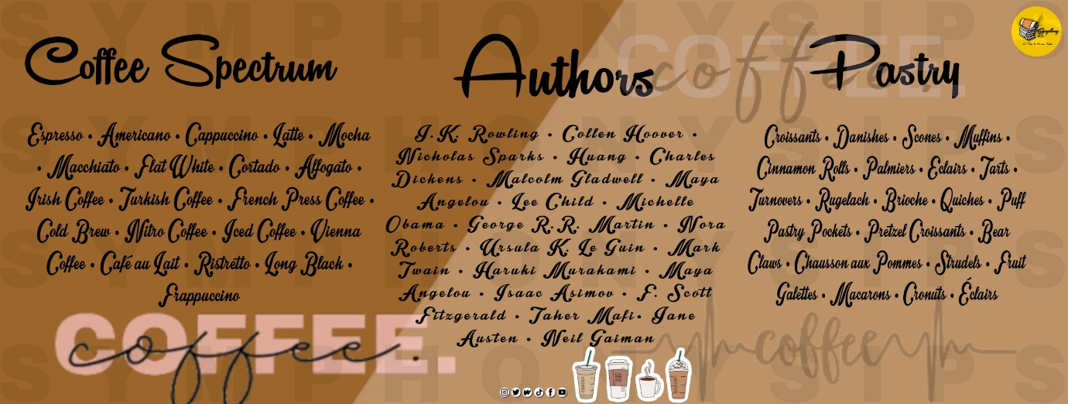

* User Flow:

User flow is a concept in user experience (UX) and web/app design that describes the paths a user follows when interacting with a digital product, such as a website or mobile app. It focuses on how users move from one screen or step to another to complete specific tasks or achieve their goals.

* Wireframes:

Introduction to wireframes that provide a skeletal structure of the user interface.

5.2 BRANDING INTEGRATION AND CUSTOMIZATION:

* Visual Branding:

Visual branding is a fundamental component of a company's or project's brand identity. It encompasses the visual elements and design choices that shape how the brand is perceived by the audience. The logo is attached below.



* Customization:

This includes the colour theme, font, text styles and the layout styles used in the process of website creation.

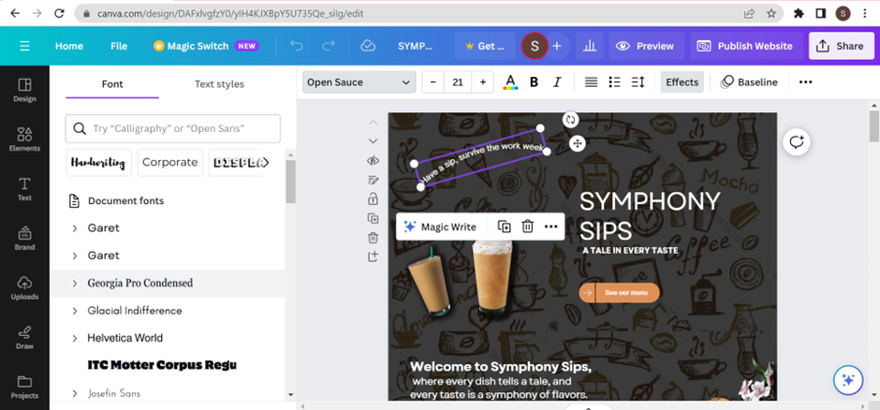

The above screenshot depicts the font used in the design.

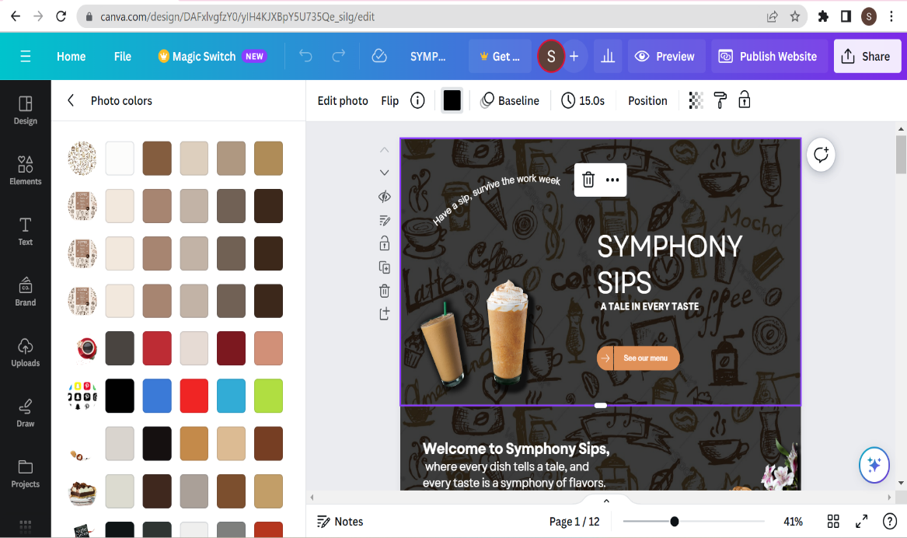

The above screenshot depicts the colour themes used in the design.

5.3 RESPONSIVE DESIGN:

Responsive design is a critical aspect of web and app development, ensuring that digital platforms adapt and function optimally on various screen sizes and devices. It involves creating layouts, content, and interactions that provide a consistent and user-friendly experience, regardless of the user's device. Responsive design accounts for the fact that users access websites and apps on a wide range of devices, including desktop computers, laptops, tablets, and smartphones. The goal is to make the platform look and work well on all of them.

DESKTOP VIEW OF THE WEBSITE:

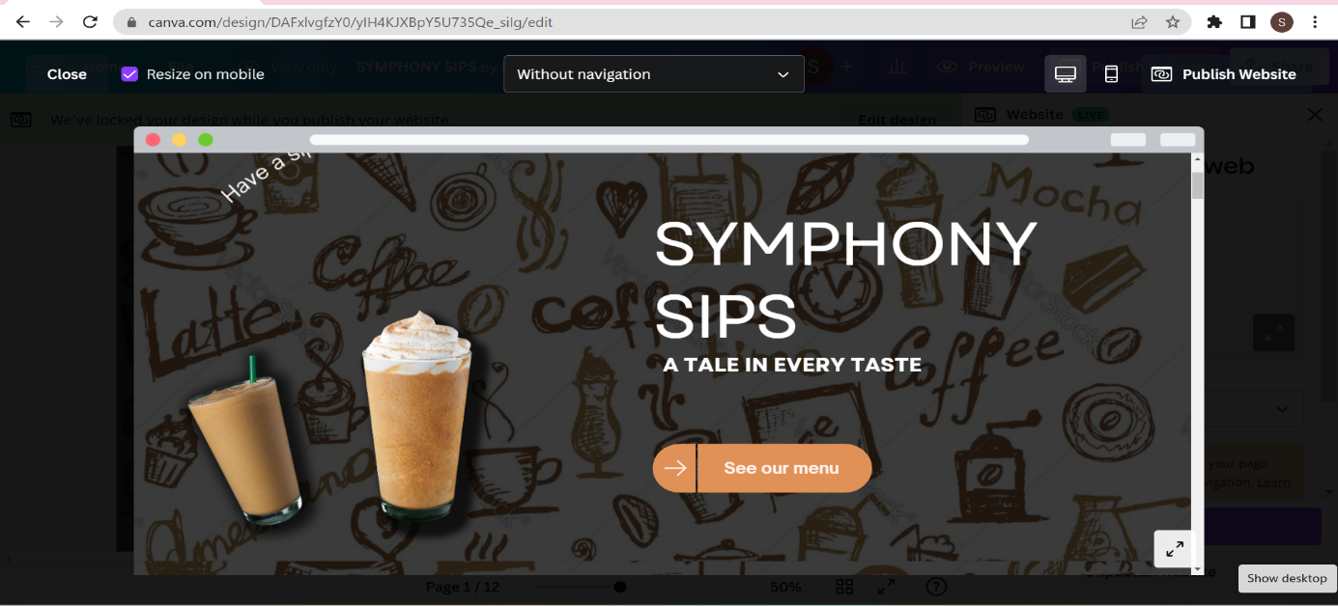

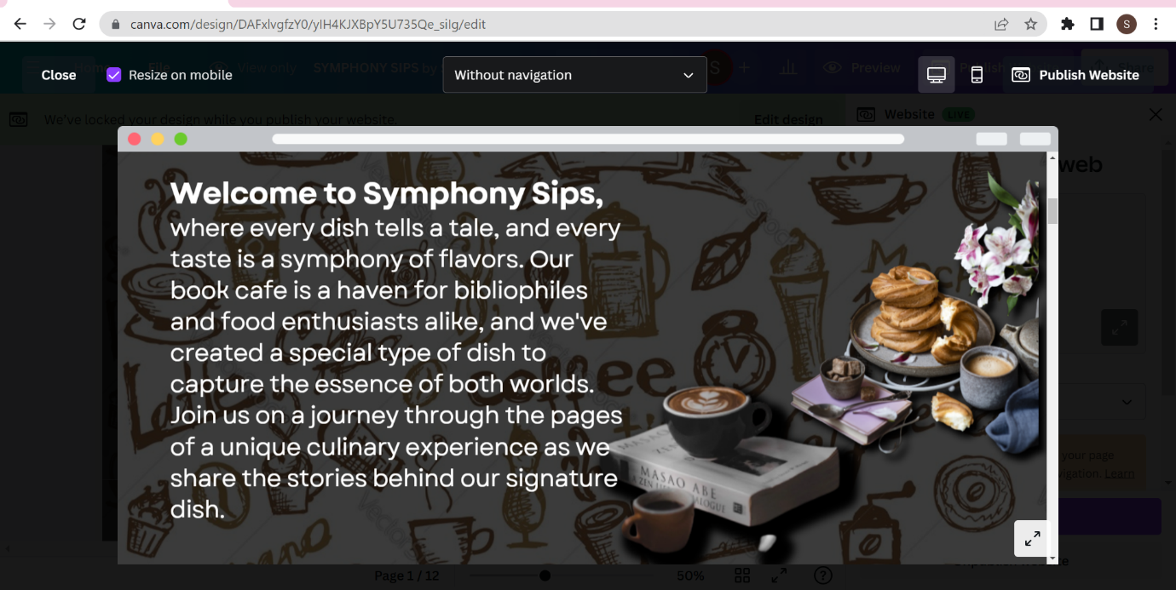

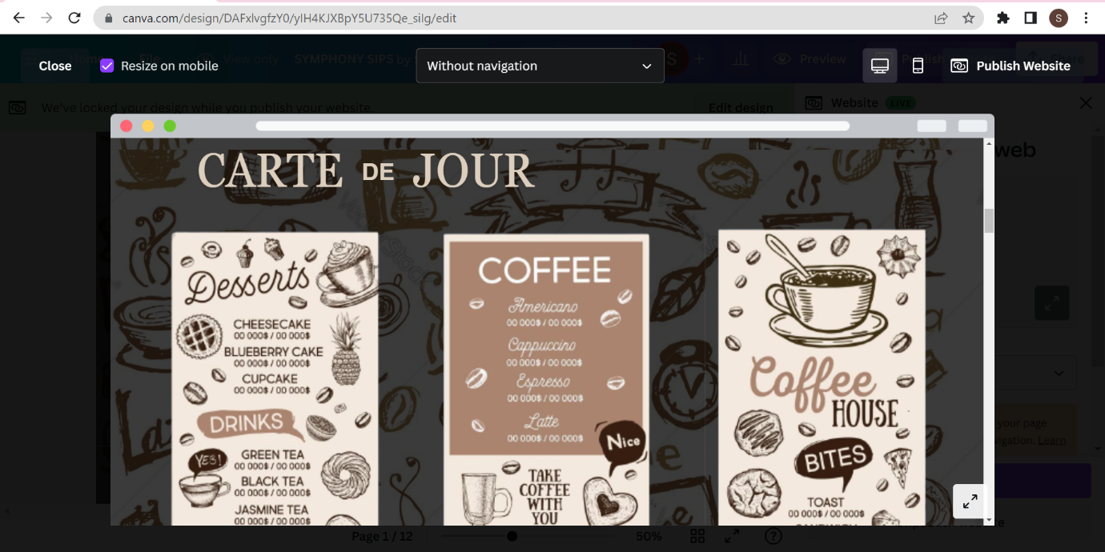

MOBILE VIEW OF THE WEBSITE:

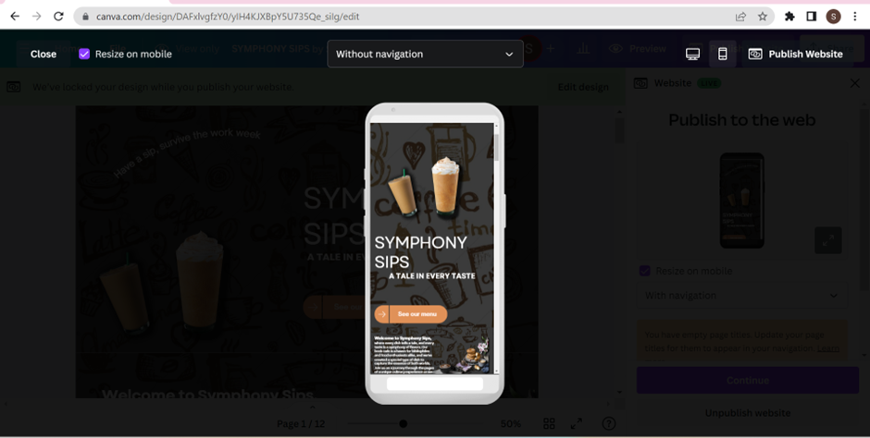

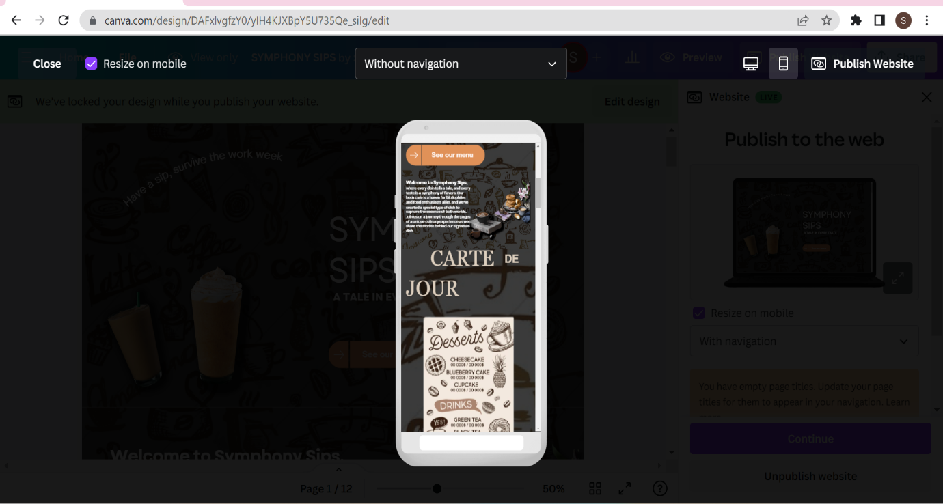

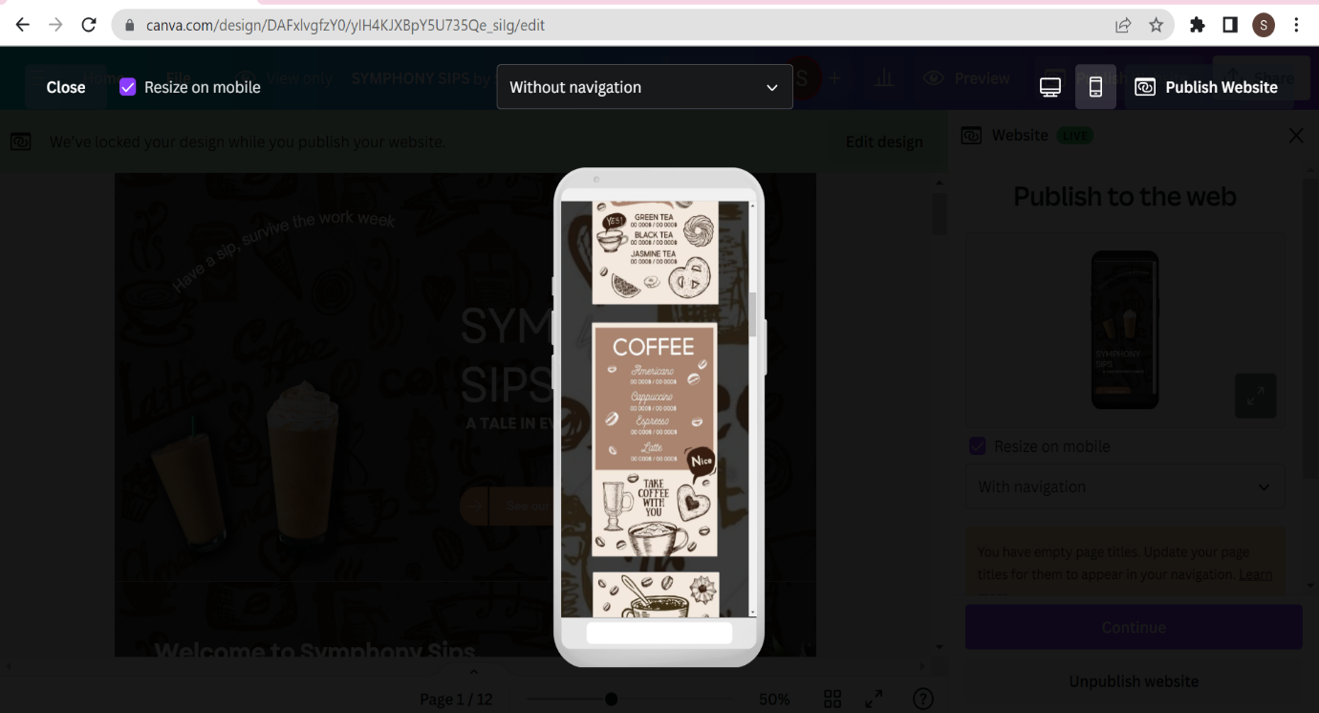

**6.DIGITAL MARKETING STRATERGY**

A digital marketing strategy is a plan that outlines how a brand or project will use digital channels and platforms to achieve specific marketing goals and objectives. It involves a range of online marketing tactics and activities to reach and engage the target audience.

6.1 RATIONABLE FOR CHOOSING DIGITAL CHANNELS AND PLATFORMS:

The choice of digital marketing channels and platforms should be based on a clear rationale that aligns with your project's goals, target audience, and overall marketing strategy. For example, in order to reach a greater number of audiences we have created a Facebook page for our book café and started advertising our café using this page. The below mentioned images shows the Facebook page and the advertisement that was created for our website.

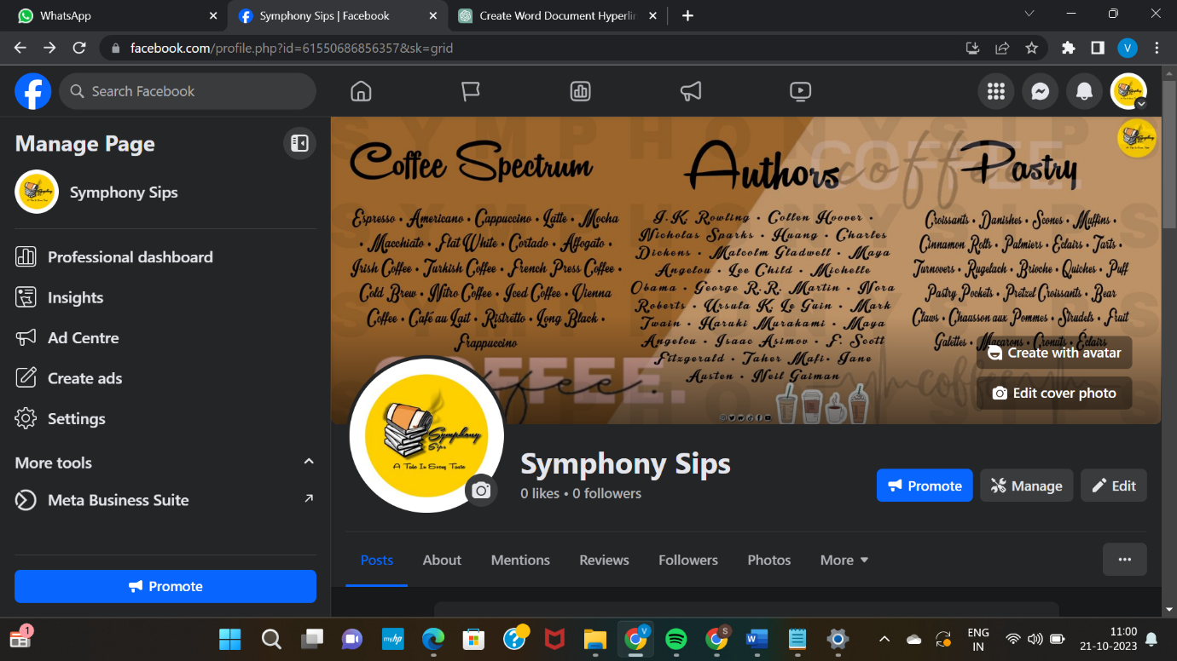

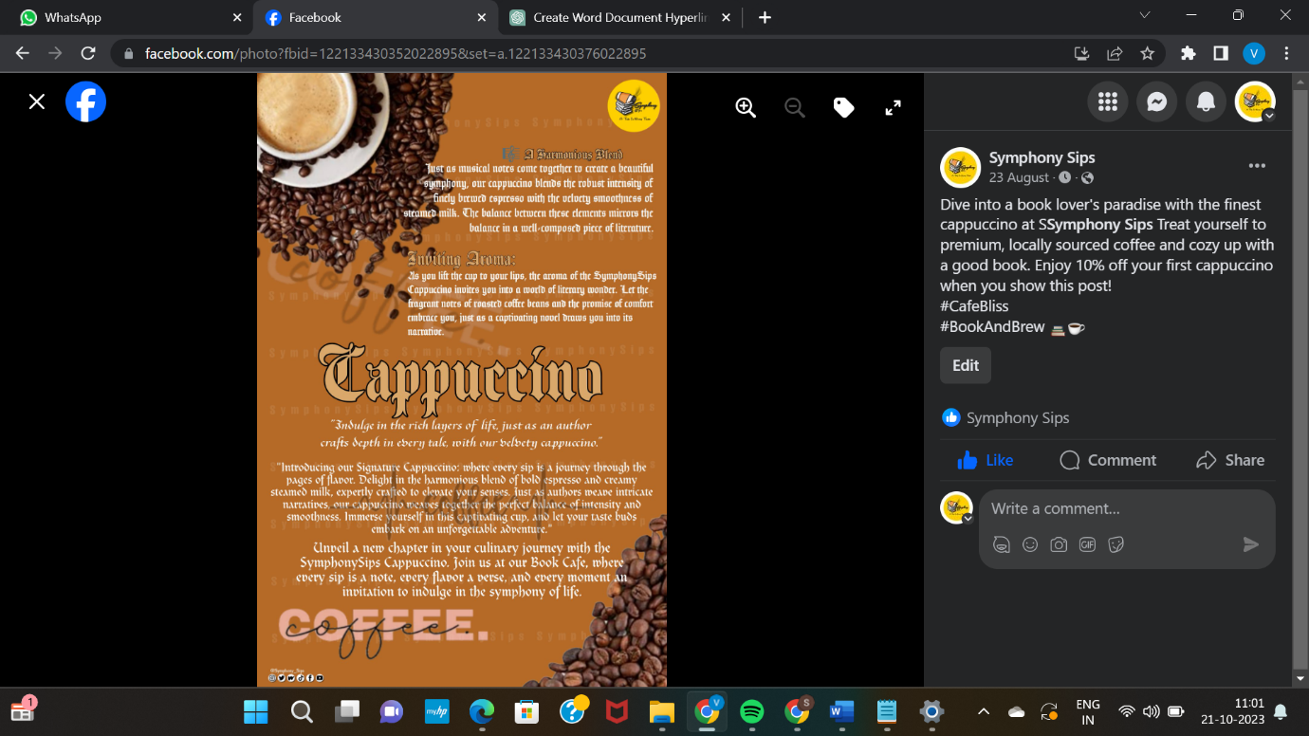

6.2 KEY MESSAGING AND BRANDING DECISIONS:

Key messaging and branding decisions are integral to the success of your digital marketing strategy. They help establish a consistent and compelling

brand identity and message across digital channels.

**7.IMPLEMENTATION PLAN**

In this section, we provide a step-by-step guide to creating a website for a book cafe using Canva.

**Step 1: Set Up Your Canva Account**

Navigate to <http://www.canva.com/> and sign in or create a new account that is created for your brand.

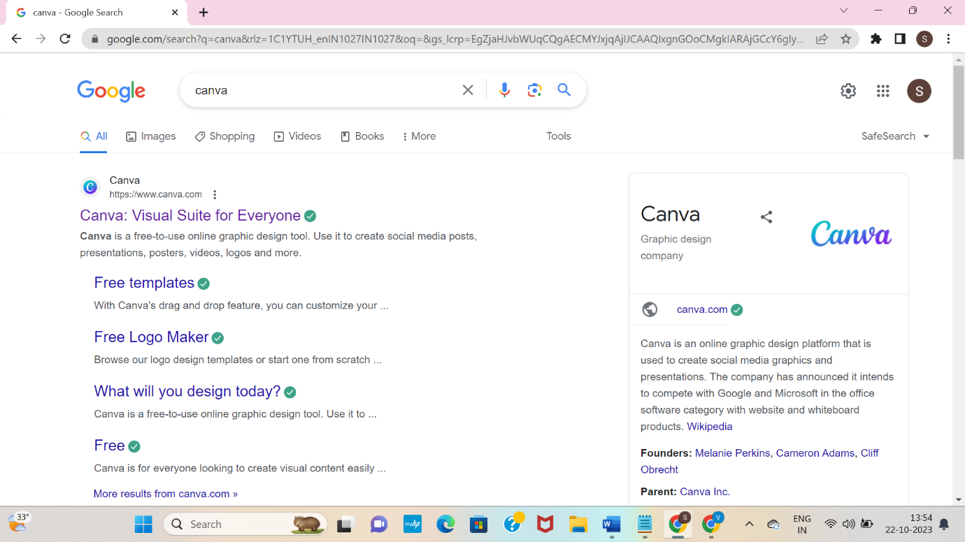

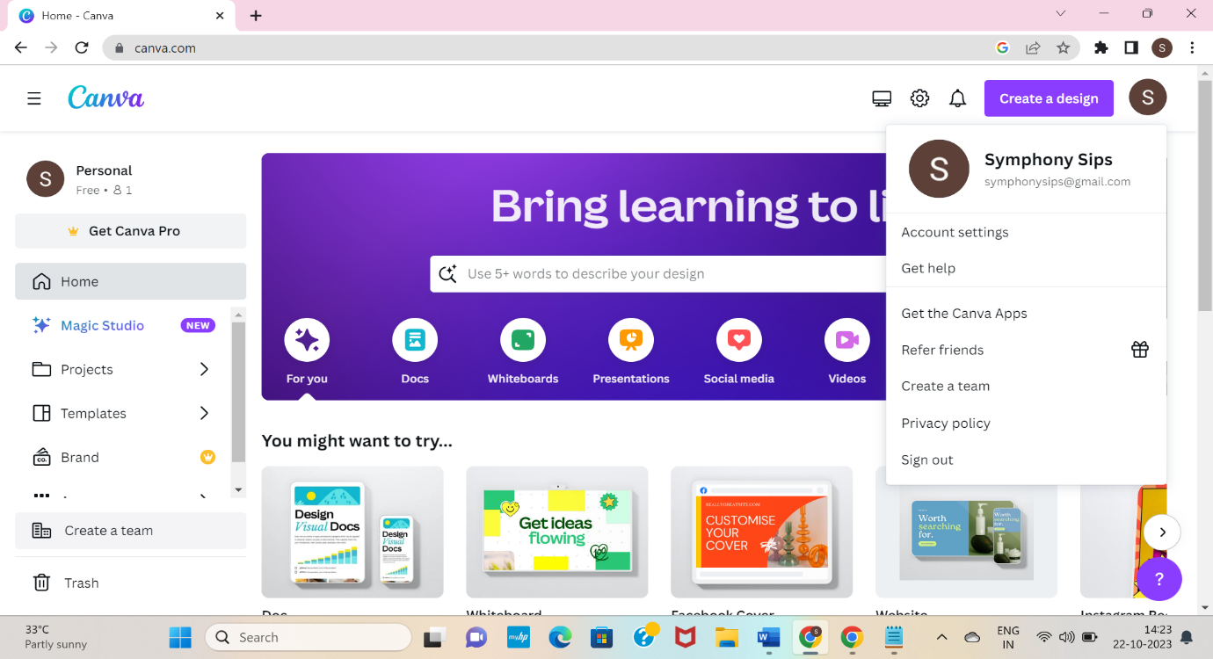

**Step 2: Click the Create Design.**

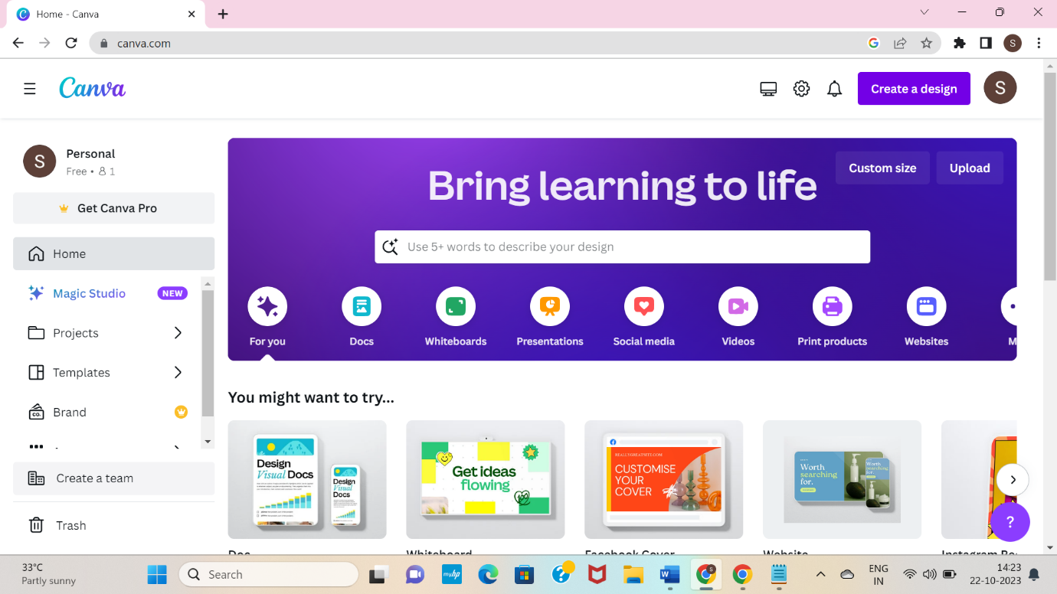

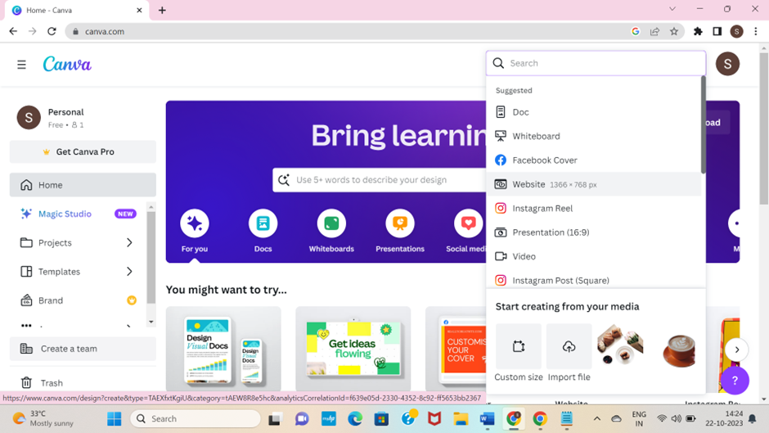

**Step 3: Search and Click ‘Website’**



**Step 4: Search and Click ‘Online Store’, choose the design according to the brand**.

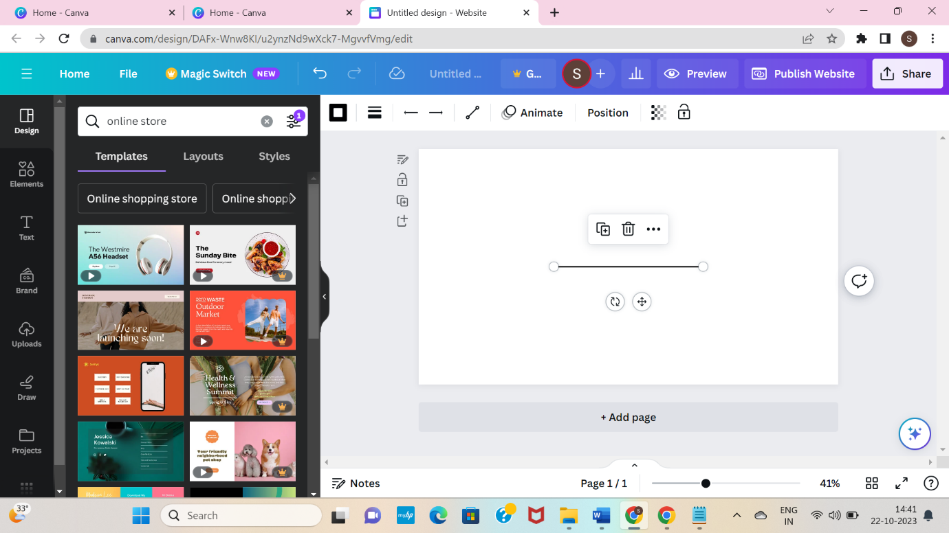

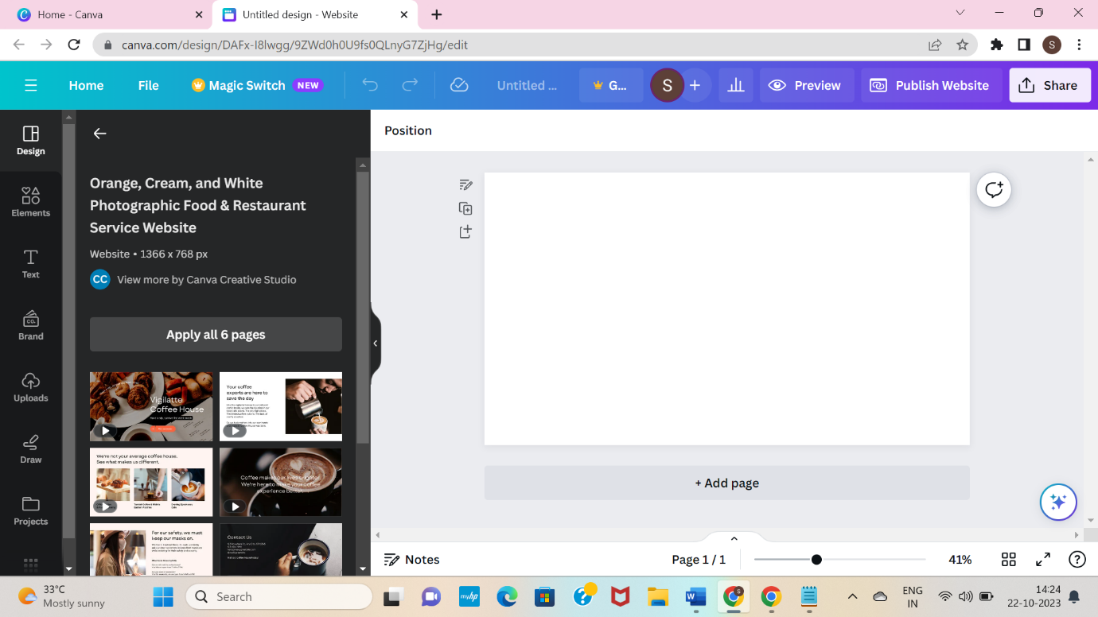

**Step 5: After choosing the template, change the background and start editing it.**

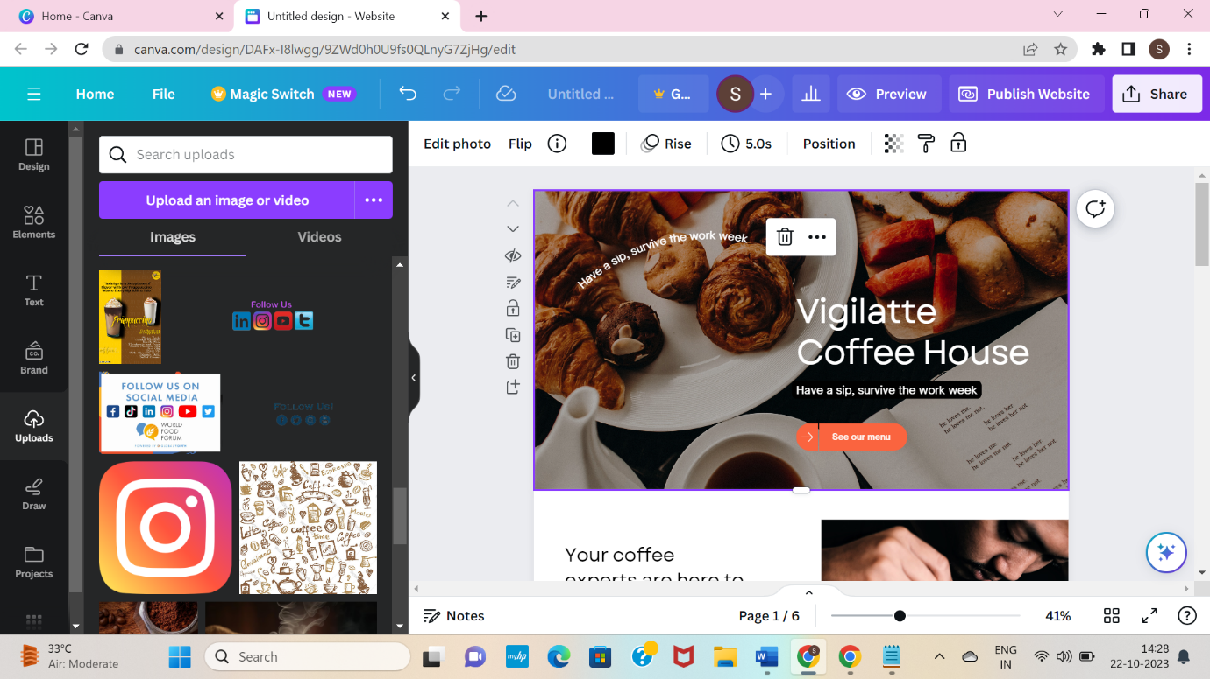

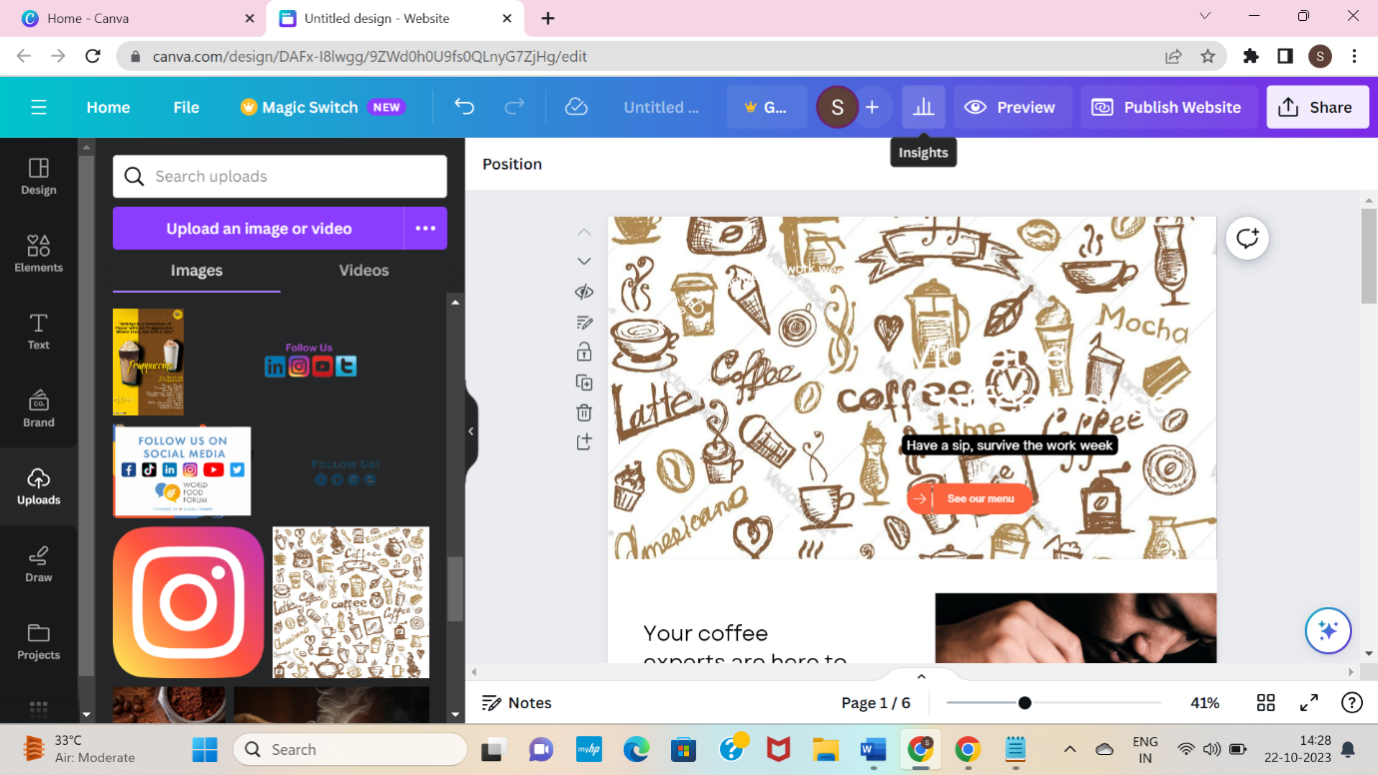

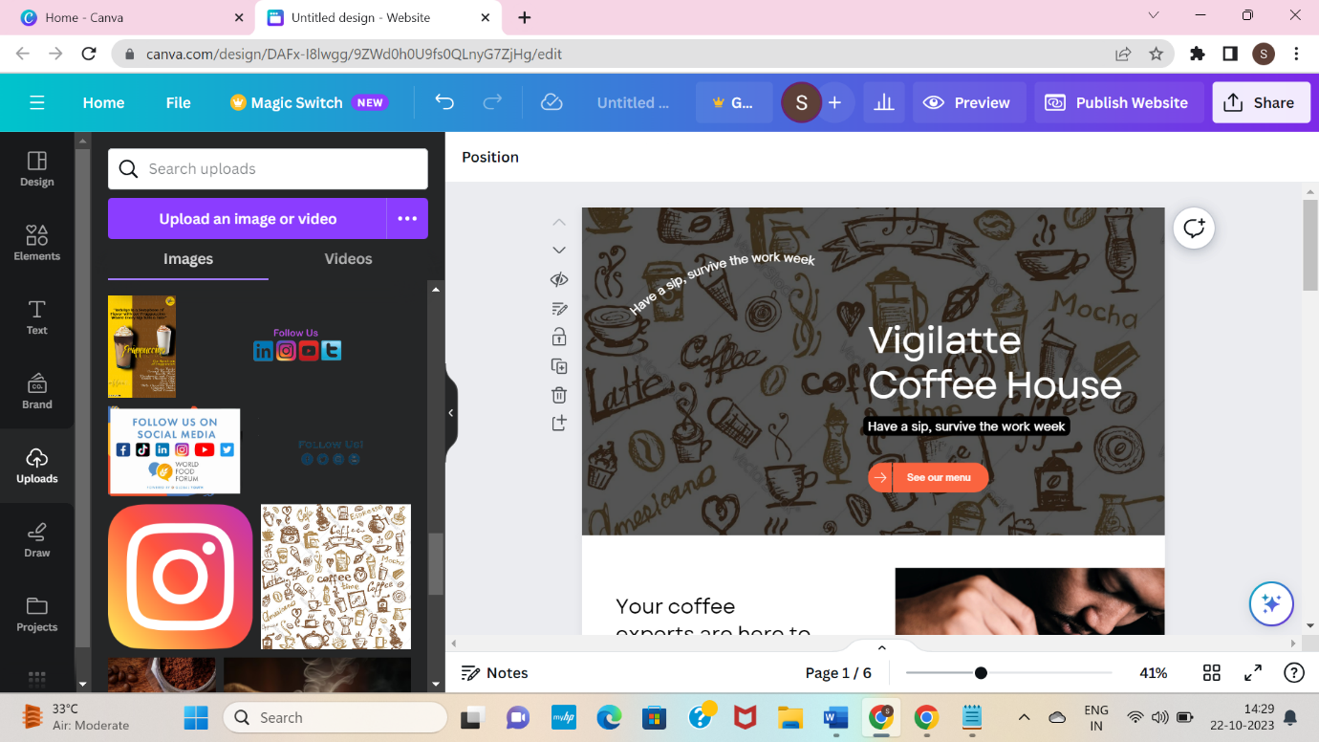

**Step 6: Add the title of the brand to the selected design.**

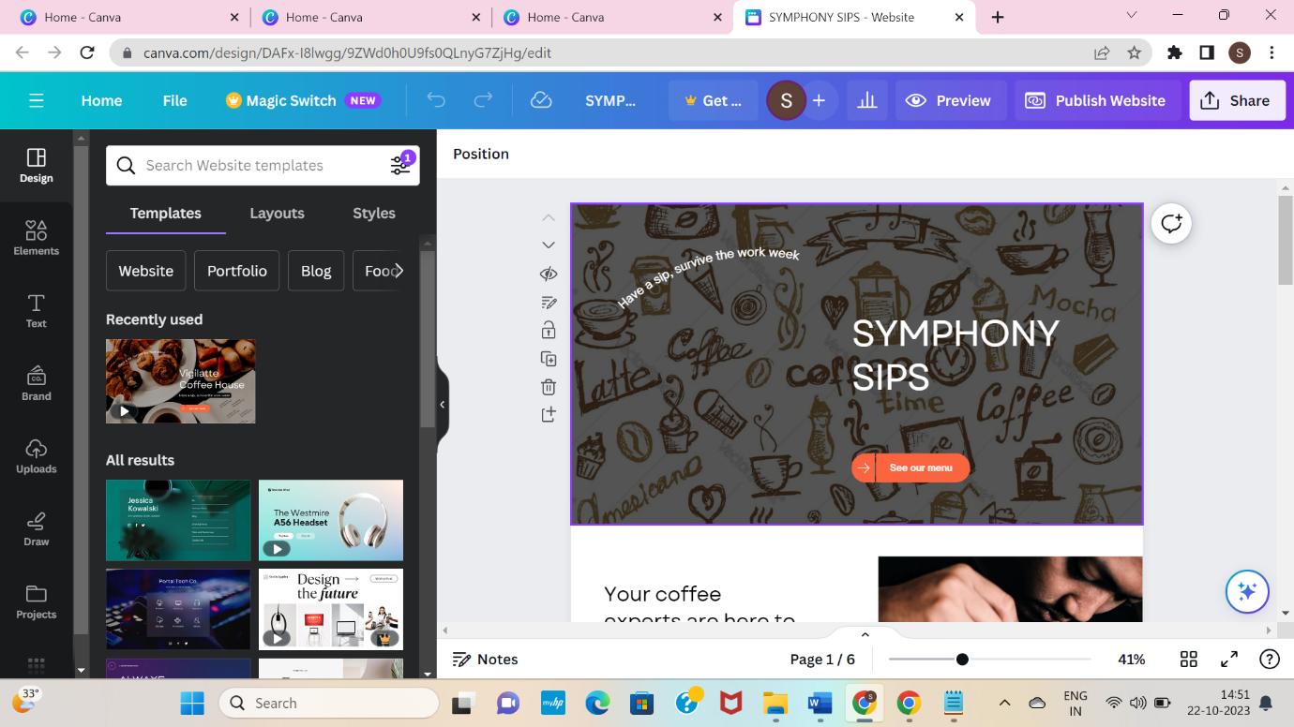

**Step 7: After finishing the editing, publish your website. Before publishing it see the preview, customize the URL and publish it.**

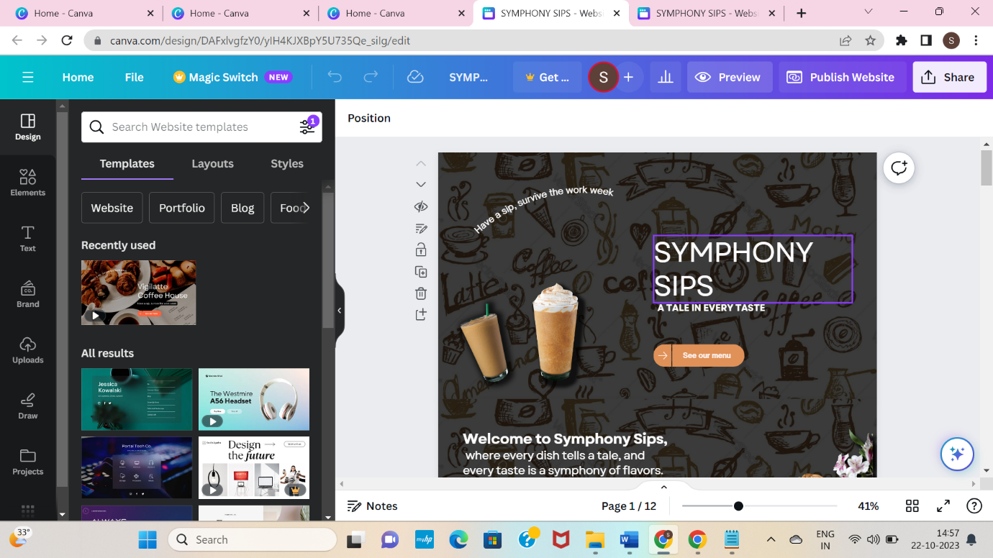

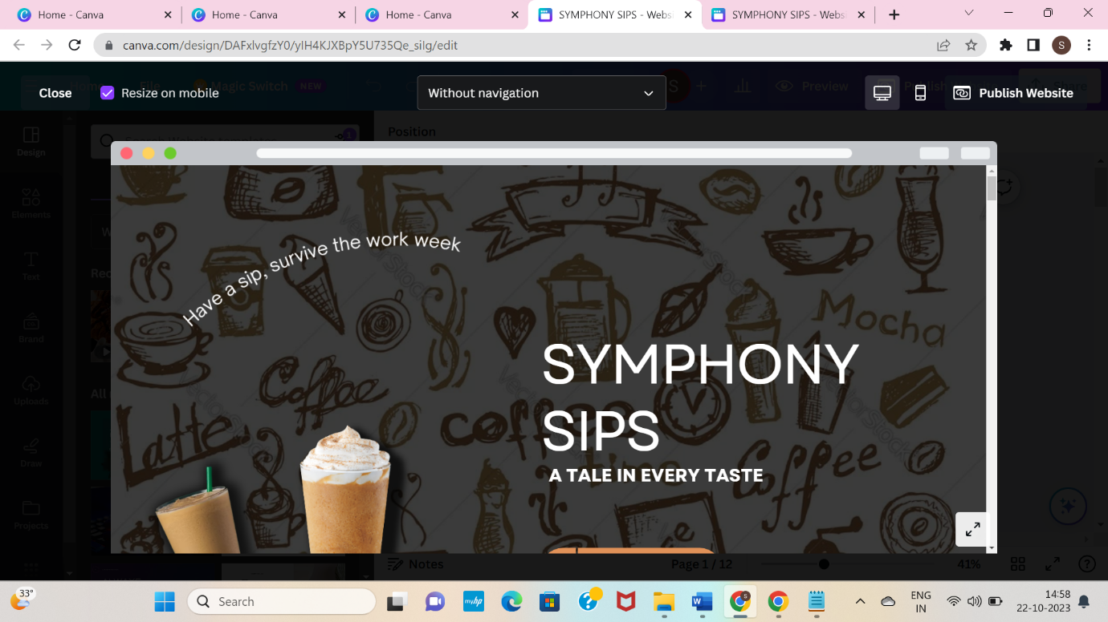

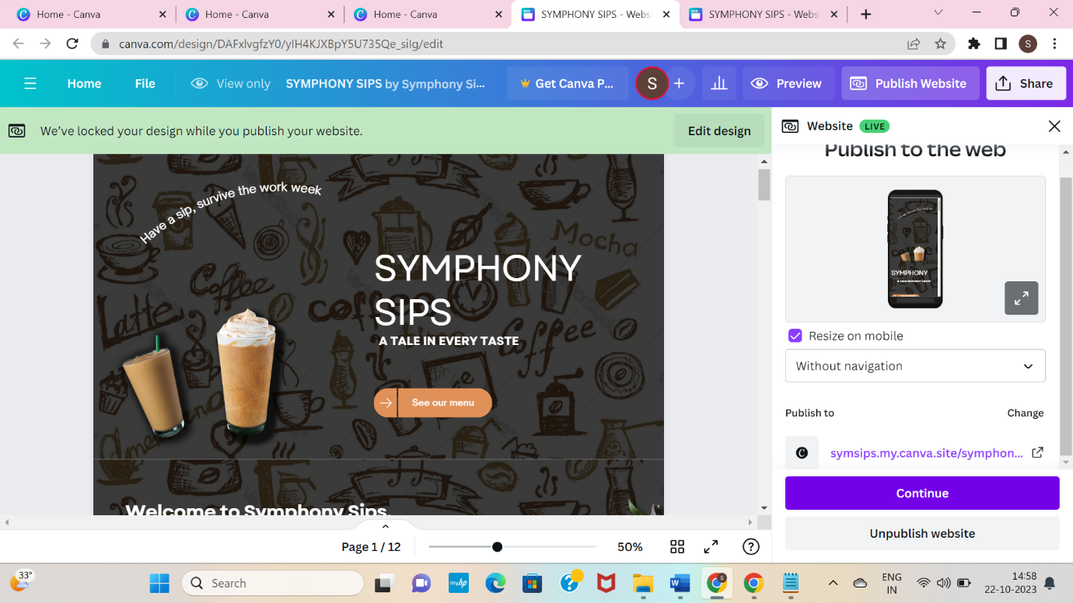

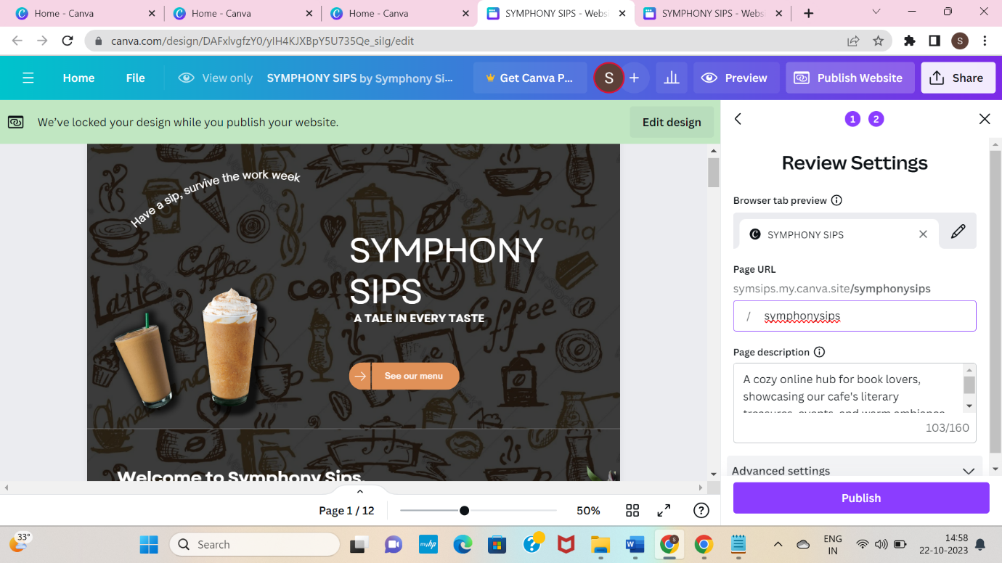

**Step 8: Click Publish and view the created website.**

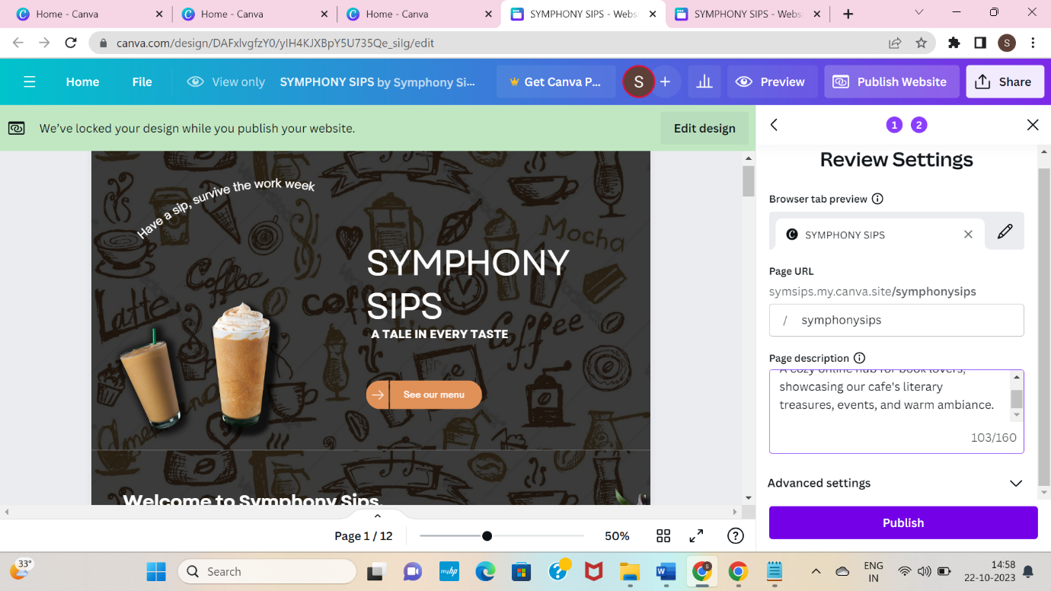

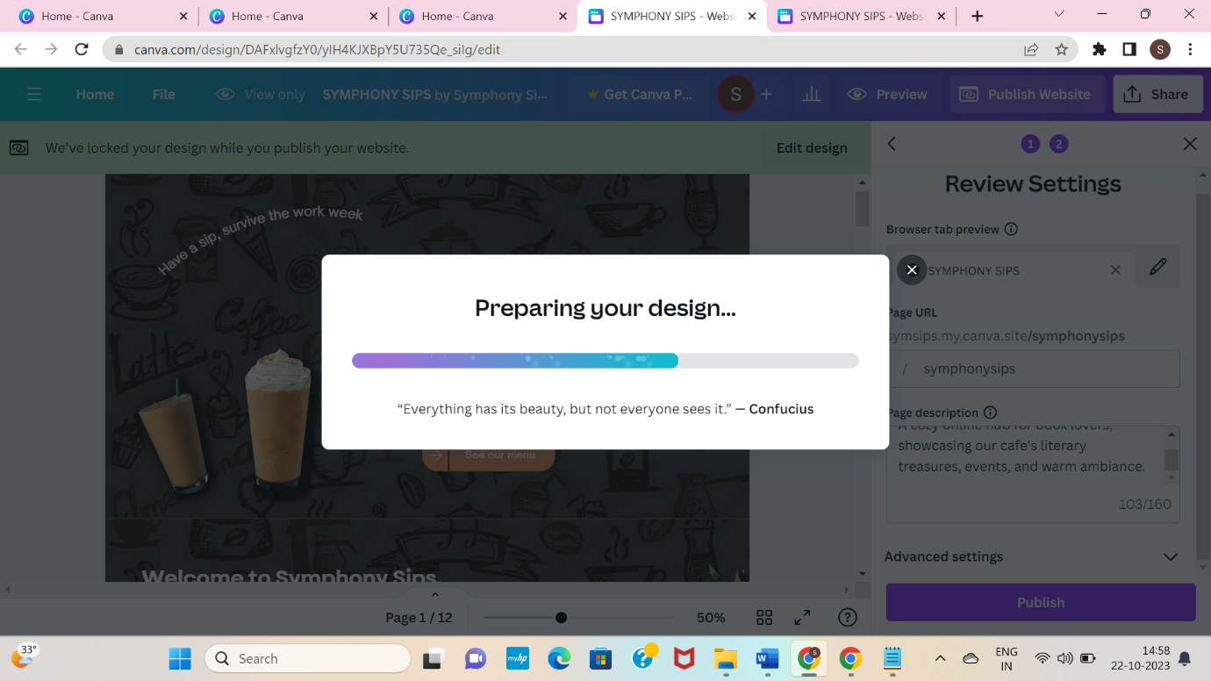

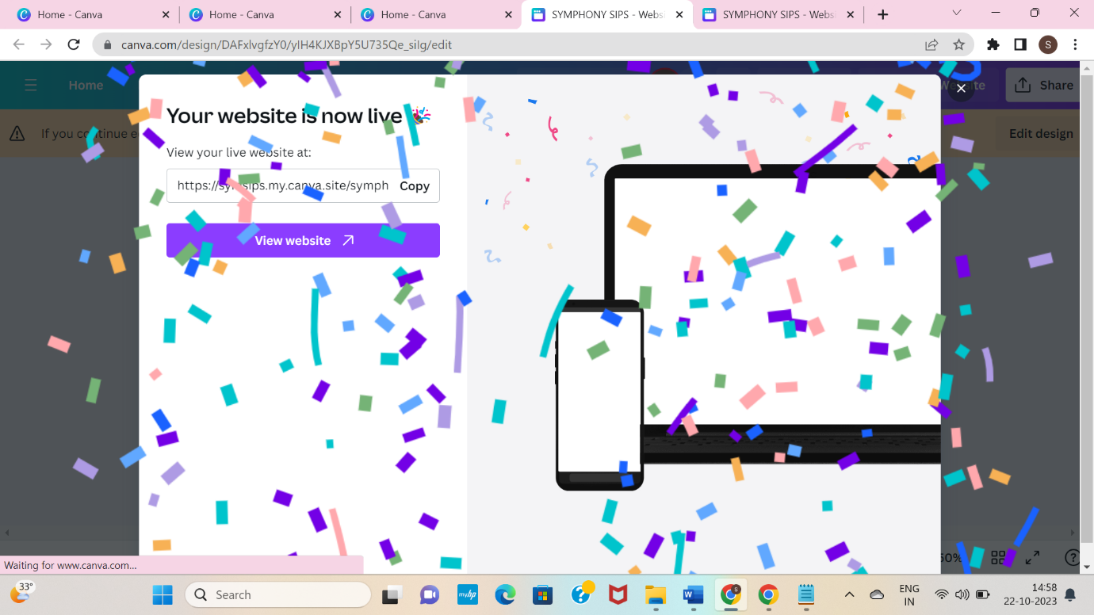

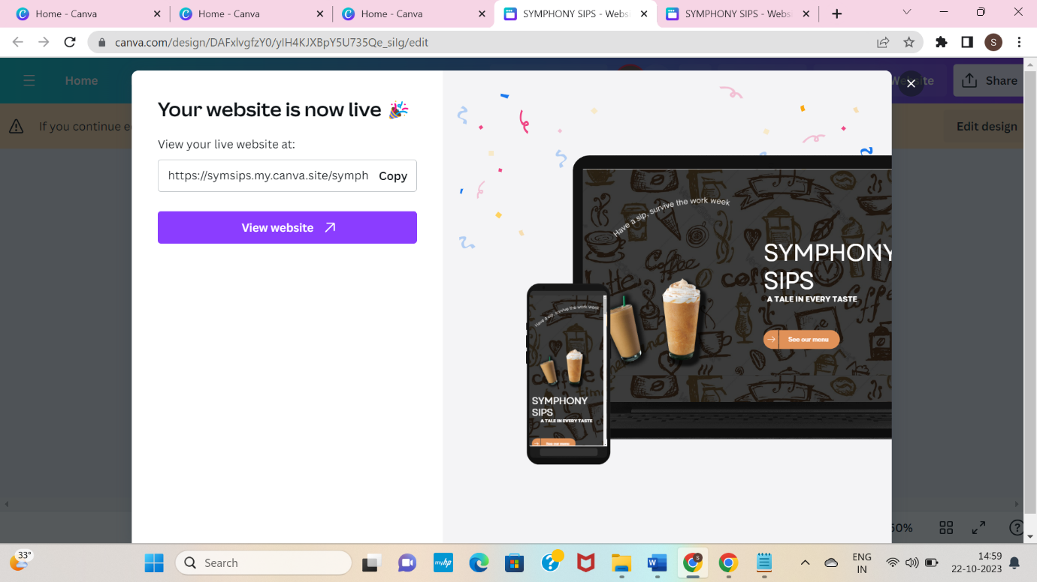

**WEBSITE LINK:**

<https://symsips.my.canva.site/symphonysips>

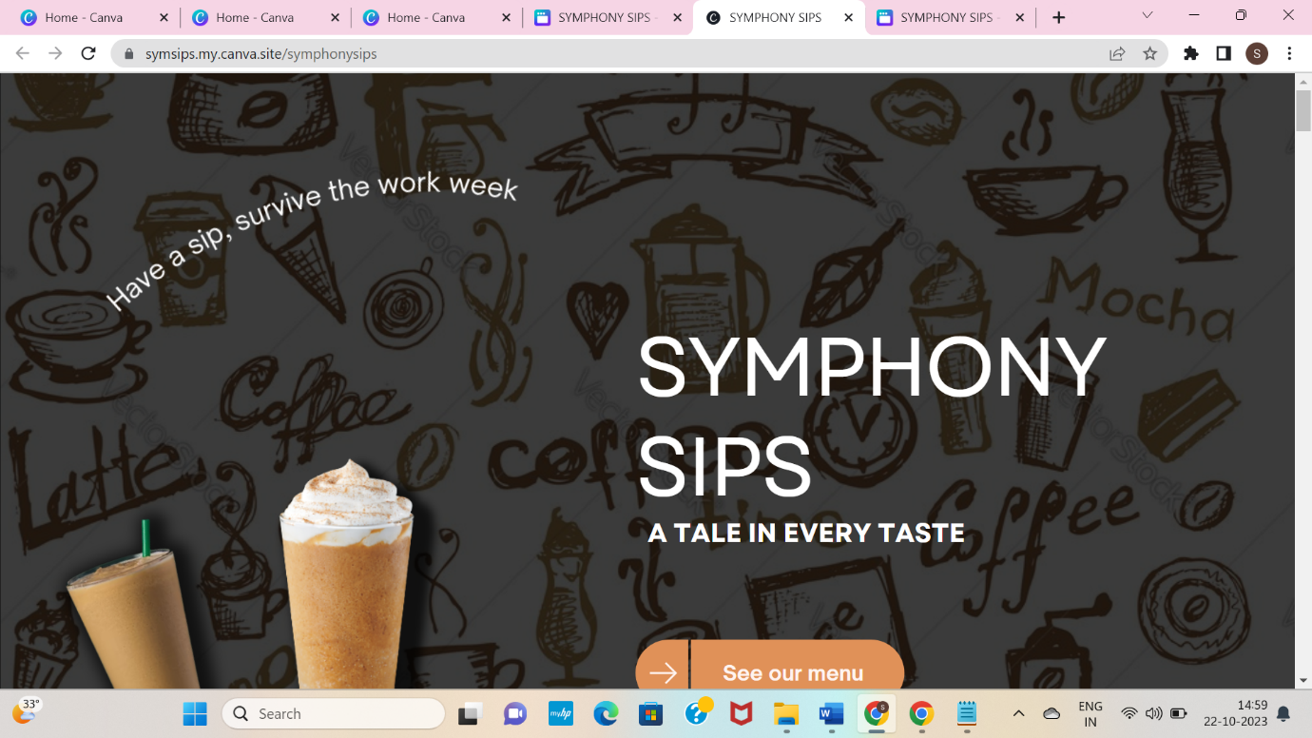

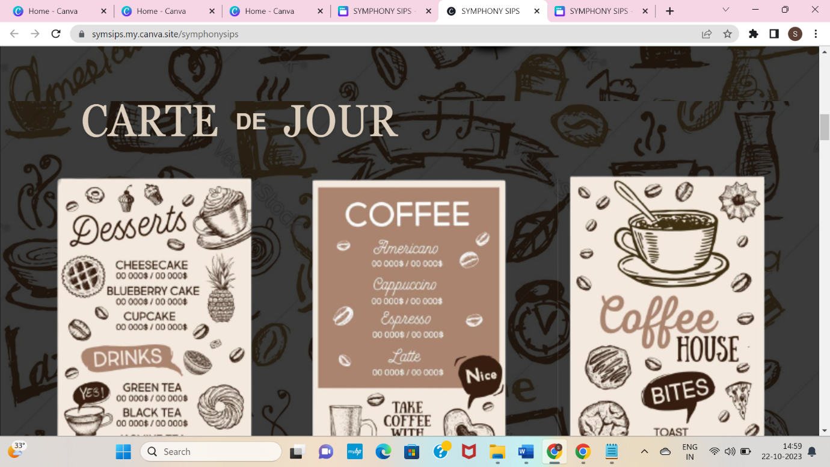

**8. RESULT AND ANALYSIS**

This section reviews the project's outcomes and assesses its effectiveness. It covers quantitative results, qualitative insights, campaign performance, conversion rates, ROI analysis, user behaviour, and lessons learned. Recommendations for future strategies and next steps are provided to guide future decision-making.

* Key Performance Indicators (KPIs):

Our project was guided by specific KPIs, including website traffic, conversion rates, social media engagement, and email open rates, to gauge our success.

* Quantitative Results:

We present the data and statistics related to these KPIs, revealing the project's performance compared to initial baseline metrics. Visual representations in the form of charts and graphs help illustrate these results.

* Qualitative Insights:

Additionally, we delve into the qualitative aspects of the project, considering user feedback, customer reviews, and survey responses. These insights provide a nuanced understanding of the user experience.

* Campaign Performance:

A detailed evaluation of our digital marketing campaigns and strategies is provided, shedding light on the most effective tactics and areas for improvement.

**9. RECOMMENDATION FOR THE FUTURE**

To ensure the continued success and growth of the project, it is advisable to align objectives with evolving market dynamics, refine the target audience, explore new content strategies, embrace emerging technologies, and diversify digital marketing efforts. Additionally, continuous improvement in conversion rates, budget flexibility, and staying competitive through insights from competitors are essential. Planning seasonal campaigns, integrating social responsibility initiatives, and preparing for crises will enhance the project's long-term sustainability and impact. Encouraging team development, maintaining a feedback loop, and emphasizing documentation and reporting further contribute to the project's forward progress and adaptability. This includes,

* Objective Alignment:

Ensure project objectives stay aligned with changing market dynamics and consumer preferences.

* Audience Adaptation:

Continuously refine the target audience to remain relevant and effectively engaged.

* Content Strategy Updates:

Explore new content themes and formats in line with audience interests and industry trends.

* Technology Utilization:

Stay updated with technology and consider integrating new tools and platforms for enhanced project performance.

* Digital Marketing Diversification:

Evaluate new digital marketing channels and adjust resource allocation based on performance.

* Conversion Enhancement:

Implement A/B testing and landing page optimization for improved user engagement and conversion rates.

* Budget Flexibility:

Review budget allocation to match evolving objectives and performance insights.

* Competitive Insights:

Learn from competitors' successes and shortcomings to fine-tune your strategies.

* Seasonal Engagement:

Plan for seasonal campaigns to maintain project relevance and engagement.

* Embrace Trends:

Stay ahead by adopting emerging industry trends and technologies for competitive advantage.

* Data-Driven Decisions:

Invest in data analytics for better performance tracking and decision-making.

* Social Responsibility:

Integrate social responsibility initiatives to enhance the project's reputation and resonate with modern consumers.

* Crisis Preparedness:

Ensure a robust crisis management plan is in place to address unforeseen challenges effectively.

* Team Development:

Encourage ongoing team training to stay updated on industry best practices.

* User Feedback Loop:

Continuously collect and analyse user feedback for ongoing improvements and a positive user experience.

* Documentation and Reporting:

Emphasize maintaining detailed documentation and regular reporting to track progress and make informed decisions.

* Long-Term Strategy:

Plan for the project's evolution, adapting to changing market conditions and audience preferences over time.

**10. SCOPE OF THE PROJECT**

The "Project Scope" section outlines the boundaries and limitations of the project. It defines what the project will and will not cover and sets expectations for what can be achieved.

* Scope Definition:

The project's scope is to create a user-friendly website for the book cafe. The primary objectives are to showcase the cafe's offerings, enable online reservations, and provide information about upcoming events. This scope includes website design, development, content creation, and basic SEO integration.

* Project Deliverables:

The project will deliver a fully functional website that incorporates the cafe's branding, menu information, event details, and a reservation system. Additionally, it will include an accessible content management system for easy updates.

* Inclusions:

Within the project scope, the following elements are included:

* + - Website design and development
    - Branding integration
    - Menu information and event pages
    - Online reservation system
    - Basic SEO for improved visibility
    - Content management system for easy updates
* Exclusions:

The project scope does not encompass the following elements:

* + E-commerce functionality for book sales
  + Extensive custom programming or complex integrations
  + Advanced SEO or long-term marketing campaigns
  + Extensive data analysis or user behavior tracking
* Constraints:

The project is constrained by budget limitations, a timeline of 12 weeks, and available in-house resources for design and content creation. Any significant scope changes must be evaluated for their impact on these constraints.

* Assumptions:

The project assumes that the cafe's branding and content are readily available. It also assumes that the target audience's preferences and needs are well understood.

* Change Management:

Scope changes will be evaluated and approved by the project manager, with a focus on maintaining alignment with the cafe's goals, budget, and timeline. Small changes can be accommodated without formal approval, but significant changes require a formal review.

* Project Acceptance Criteria:

The project will be considered complete when the website is fully functional, has passed quality assurance tests, aligns with the cafe's branding, and meets the criteria defined in the project plan.

* Rationale:

The defined scope aims to balance the project's objectives with available resources and constraints. It aligns with the cafe's immediate goals of establishing an online presence and facilitating reservations while adhering to budget and time limitations.

**11. CONCLUSION**

In conclusion, the successful creation of our book cafe's website is a significant achievement. It provides a valuable platform to connect with our audience, showcase our offerings, and streamline reservations. This project exemplifies our commitment to enhancing our online presence and customer experience. As we move forward, we're excited about the opportunities this website offers for growth and continued success.

**12.APPENDIX**

GITHUB LINK AND DEMO VIDEO LINK

**GITHUB LINK:**

<https://github.com/yuva-1705/Digital-Marketing/tree/main>

**DEMO VEDIO LINK:**

<https://youtu.be/6Gr9LVTF_OM?si=PiolT4x8TjPeN1Yl>